How to register and edit the registration?
Please read through these instructions as well as the conditions for registration, attendance and cancellation (https://kaiku2026.fi/en/osallistujalle/ehdot)
The major difference between the default registration form and the international group registration process is how the attendance fee is paid: individual participants pay on-line immediately whereas when the group registration form is used the attendance fee will be invoiced from the National Scouting Organization (NSO) which in turn will then collect the fees from its members.
If you are the group leader of an international group, you need to register your group. Scroll down for the instructions!
If you are an individual international participant, in other words an IST (international service team member), please use the “basic” registration form. It is available in three languages: Finnish, Swedish and English. This form requires you to pay the registration fee on-line right after submitting the form.

Quick and dirty instructions for Group leaders and ISTs
- Please navigate to the registration form at https://kuksa.partio.fi/Groups/group.aspx?tid=74058.
- First select the option ”sign up”.
- Give your group a name, select your country, and give some information about the members of the group. How many? Which ages?
- Save the group registration form
- After you save the ”group registration form”, you will be asked to fill in your personal info on e.g. diet
- Fill in the required information carefully. Pay extra attention to the fields marked as ”mandatory” with an asterix (*)
- Remember to enter the billing information for your group/ for you as an IST)
- Choose ”Sign up” at the bottom of the page
- You should see a screen titled ”Group information”. If you do not see it, scroll to the top and check what is missing. fill it in
- When you see the screen for ” Group information”, your registration is OK!
- Make a note of /copy both the Group registration code and the group leader registration code (for ISTs, that is your own code!)
- You will also receive a confirmation e-mail. The registration code is at the very bottom of the message , for example: “Welcome along! Your registration code to the event is: xxx-c951-xx-xx-x.”
- You can now either distribute the group registration code to the group members OR add them yourself, if you have their info
- The invoice will be sent to the national scout organization. After the participation fee is paid in full, the participation is confirmed

Editing the registration information (of individual participants only)
You can edit the health & dietary information in Kuksa until May 10, 2025. After this any changes need to be informed to the project office at kaiku2026@partio.fi.
Members & their guardians:
- Log in to kuksa.partio.fi using your own credentials (Partio-ID) or your guardian credentials (Huoltaja-ID)
- Navigate to the persons’ names in the upper right-hand corner and select the correct person’s information
- Select tab “Events” and locate Uusimaa - Kaiku 2026. Then select Edit on the right.

Non-members:
Use the same link you used when registering and enter your registration code. Alternatively, you can contact the project office at kaiku2026@partio.fi.

Registration process for international groups
The group registration form should only be filled in by the leader of each national group! https://kuksa.partio.fi/Groups/group.aspx?tid=74058
Please be very careful when selecting which registration form to use.
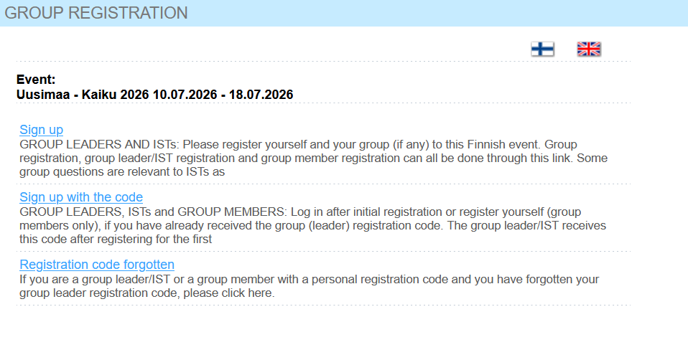
For Group leaders
- As the group leader, choose “Sign up”
- After submitting the group form, you will be asked to enter your own personal information.
- Once you get the group registration code, you have two options: you can distribute the group registration code to members of your group or add each of them yourself
- The invoice for the group registration will be sent to the national scouting organization (NSO). The registration of the group and each member is only valid after the Organizer has received the payment in full
Instructions for group leader registering the group and him/her/themself
- Select the correct form
- Give the group information
  - Group name (e.g. Honolulu contingent)
  - NSO (the national scouting organization your group represents)
  - City and county
  - More information, for example “5 boys and 4 girls from country X, aged 14-16. 2 adult leaders. 1 person with wheel chair”
  - Group leader: name, contact details
- Submit the group registration
- Carefully enter your own data including e.g. birth date and possible dietary restrictions
- Enter the NSO details as the payment address
- Save the group registration
- Take note of the group registration code – you can e.g. copy and paste it or even write it down!
- Navigate back to the group registration page and select the “sign up with the code”. When you scroll down, you can choose an “Add member”. OR you can distribute the group registration code to your group members and ask each of them to enter their own information
- Upon request, you will receive a list of the group members and their data for the Kaiku2026 office

For members of international groups
Please use the option “register with a group code”. Please note that your information needs to be entered just once, by either yourself or by the group leader: not both!
- Get your participant code from your group leader
- Select the 3rd option “sign up with the code”
- Enter the group code
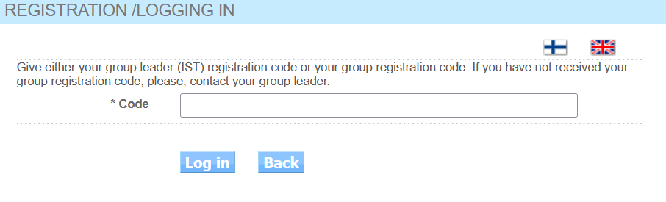
- Enter the required information carefully
- Submit the request
- If you need to adjust your registration in any way, please contact your national group’s leader

Registration process for individual international participants
You will use the same registration as group leaders
https://kuksa.partio.fi/Groups/group.aspx?tid=74058
1. Choose “Sign up”. (It says group leaders but don’t worry about it. You are your own “group”)
2. Give the group information
- Group name = Your name
- NSO (the national scouting organization you represent)
- City and country
- Group leader: your name, contact details
3. Submit the group registration
4. Carefully enter your own data including e.g. birth date and possible dietary restrictions
5. Enter the NSO details as the payment address
6. Save the group registration
• The invoice for the registration will be sent to the National Scouting Organization (NSO). The registration is only valid after the organizer has received the payment in full.

